Box 2.1

Mainland’s export market diversification
Mainland’s merchandise exports have continued to demonstrate remarkable resilience despite elevated global trade tensions and shifting geopolitical dynamics over the past decade. During 2014 to 2024, the value of Mainland’s merchandise exports rose from USD 2.3 trillion to around USD 3.6 trillion, marking an average annual growth of 4.3%, visibly outpacing the global average of 2.5%. Consequently, its share of world merchandise exports increased from 12.3% in 2014 to 14.6% in 2024, surpassing other major economies and staying as the world’s largest merchandise exporter (Chart 1). A key driver of this positive trend is the changing market structure, as Mainland’s exporters diversified their global presence and expanded into various markets.
Chart 1 : Trends in world merchandise export shares: Mainland vs other major economies
(2014–2024)
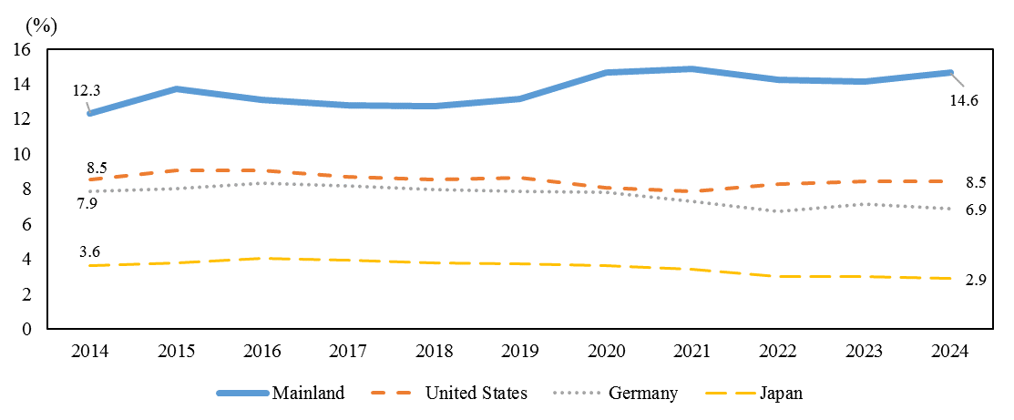
Source: World Trade Organization
Shifting Export Market Structure

The market structure of Mainland’s merchandise exports has changed dramatically and become more diversified over the past decade. A notable trend is the declining reliance on traditional markets. For instance, while exports to the US grew at an average annual rate of 2.9% from 2014 to USD 525 billion in 2024, its share in Mainland’s exports dropped visibly from 16.9% to 14.7% over the period. The share fell further to less than 12% in the first half of 2025 in tandem with lingering uncertainties of US’ tariff policies, reflecting the ongoing efforts of Mainland exporters to seek opportunities in other markets as global trade tensions have intensified since 2018. Similarly, Mainland’s exports to some other major traditional markets such as the Japan, Netherlands and UK increased at an average annual rate of 0.2%, 3.5% and 3.3% respectively from 2014 to 2024, but their shares in Mainland’s exports also fell from 6.4%, 2.8% and 2.4% in 2014 to 4.3%, 2.5% and 2.2% respectively in the first half of 2025.

Box 2.1 (Cont’d)

In contrast, the shares of emerging markets and developing economies in Mainland’s exports increased. The shares of exports to ASEAN and Latin America economies, both being major forces of Mainland’s exports, surged from 11.6% and 5.8% respectively in 2014 to 16.4% and 7.7% in 2024, and further to 17.8% and 7.8% in the first half of 2025. Specifically, Mainland’s exports to Vietnam and Malaysia grew strongly, rising by 9.8% and 8.1% respectively per year on average from 2014 to 2024. Meanwhile, exports to Mexico and Brazil also experienced notable growth, surging markedly by 10.8% and 7.5% respectively per year on average during the same period. Mainland’s exports to Africa and the Middle East also expanded, albeit at a relatively moderated pace (Table 1). The share of Mainland’s exports to the Belt and Road Initiative (BRI) economies⁽⁾ as a whole rose from less than 40% in 2014 to more than 50% in the first half of 2025.
Table 1: Mainland’s merchandise exports by selected trading partners
 | Share of total exports (%) |  |  | Average growth per year (2014-2024)(%)
 | 2014 | 2024 | 2025H1
US | 16.9 | 14.7 | 11.9 | 2.9
ASEAN | 11.6 | 16.4 | 17.8 | 8.0
Latin America | 5.8 | 7.7 | 7.8 | 7.4
Africa | 4.5 | 5.0 | 5.7 | 5.4
Middle East⁽⁾ | 4.8 | 4.9 | 5.2 | 4.6
Source: General Administration of Customs of the People's Republic of China

The rising importance of emerging markets and developing economies for Mainland’s exports could mainly be attributed to the deepening ties with the Global South, thereby forging new trade corridors with economies in Africa, Latin America, and beyond. The BRI has enhanced trade connectivity with member countries through various channels such as improving infrastructure - ports, railways, and digital networks. Meanwhile, bilateral and regional trade agreements, such as Regional Comprehensive Economic Partnership (RCEP) and various other free trade agreements, have improved market access through lower tariffs and more efficient customs processes, enabling the Mainland to deepen ties with the Asia-Pacific region and others. Additionally, supply chain diversification with rising outbound manufacturing direct investments has enhanced flexibility for Chinese firms to navigate global tariff barriers and respond to shifting demands across different regions more effectively, while the increasing importance of other developing Asian economies has also accelerated the growth in demand for various goods from the Mainland.

Box 2.1 (Cont’d)

Mainland’s export market diversification has also been manifested by a significant shift in product-mix toward more sophisticated goods over the past decade. The Organisation for Economic Co-operation and Development estimates that the share of traditional products, viz. textiles, wearing apparel, leather and related products, in Mainland’s exports declined from 16.3% of the total in 2014 to 11.4% in 2023. Meanwhile, the share of higher-tech products in Mainland’s total exports gained prominence. For example, the shares of electrical equipment, electronic components and boards, as well as motor vehicles and other transport equipment went up from 14.0% and 5.1% of its total exports in 2014, to 17.9% and 7.8% in 2023 respectively. This trend has aligned with the Mainland’s industrial upgrading, transitioning from labour-intensive manufacturing toward more technology- and capital-intensive sectors. The growth in exports of higher-tech products has been particularly pronounced in emerging markets such as ASEAN and some Latin America economies, where demand for machinery, electronics, and vehicles has expanded alongside infrastructure development and rising consumer purchasing power.
Implications to Hong Kong

The Mainland’s export sector has not only demonstrated exceptional resilience and adaptability over the past decade, but has also been strengthened by the ongoing diversification towards emerging markets and developing economies. It is imperative for Hong Kong as a “super connector” and “super value-adder” to adapt to these shifting patterns in order to maintain our competitive edge. With stronger trade relations with ASEAN, for instance, Hong Kong is positioned as a leading hub for multinational supply chain management to strategically align with growing Mainland’s exports to ASEAN (notably electronics-related products). Besides, Hong Kong can provide a full spectrum of professional support and financial services for trading enterprises (including Mainland enterprises), which can help them actively expand into markets along the BRI. By supporting Mainland enterprises in their innovation and upgrading efforts in expanding new business, Hong Kong does not only create opportunities for its own professional services sector, but also contributes to the national goal of high-quality development. In turn, this reinforces Hong Kong’s status as an international financial, shipping and trading centre, fostering a more resilient and dynamic economy.

() The BRI encompasses many emerging markets and developing economies globally. It includes all member states of ASEAN, the majority of countries in Latin America and Africa, and other economies. Currently, over 150 countries participate in the BRI.
() In this box article, the “Middle East” refers to Saudi Arabia, United Arab Emirates (UAE), Qatar, Iran, Iraq, Kuwait, Oman, Bahrain, Jordan, Lebanon, and Israel.

